

**Enjabulweni Independent School  
Grade 12  
Banzile Z. Nhlebela  
IT PAT  
Project Technical Document**



Contents

**Externally Sourced Code** 3

**Explanation of Critical Algorithm** 3

**Advanced Techniques** 4

**Password Eye** 4

**Display record from database in jTable** 4

**Testing** 6

**Functional Testing** 6

**Test Plan** 9

**Standard Data** 9

**Extreme Data** 9

**Abnormal Data** 10

**Evidence of Testing** 11

**Standard Data** 11

**Extreme Data** 12

**Abnormal Data** 13

**Evaluation of Solution** 14

# **Externally Sourced Code**

Below is all externally sourced code originating from different YouTube videos:

<https://youtu.be/4c3WYK5FpqI>  
<https://youtu.be/_TxQz2J9SvU>  
<https://youtu.be/_biRI1V0nxw>  
<https://youtu.be/R0sIwluImT8>

# **Explanation of Critical Algorithm**

Below is the algorithm for the most critical function of the program. This function counts the number of times a student has committed a certain type of offence and determines whether or not any action must be taken should the student commit the same type of offence a number of times too many. Without this function, the program would simply serve as a way to store and display data hence not being as useful as it should be in a school setting.

Begin method  
count(String ID, int LV)  
query 🡨 "SELECT COUNT(*) FROM `conLog` WHERE `StudentID` = '" + ID + "' AND `OffenceID` LIKE \"%" + LV + "%\";"  
execute query  
int c 🡨 query result  
begin if  
if(c >= 3)  
 Begin if  
 if(LV = 1)  
 Display “Too many level 1 offences committed. Level 2 action needed”  
 end if  
 Begin if  
 if(LV = 2)  
 Display “Too many level 2 offences committed. Level 3 action needed”  
 end if  
 Begin if  
 if(LV = 3)  
 Display “Too many level 3 offences committed. Level 4 action needed”  
 end if  
 Begin if  
 if(LV = 4)  
 Display “Too many level 4 offences committed. Must be expelled or suspended ASAP”  
 end if  
else  
Display “This student has not committed quite a number of Level” + LV + “offences”  
end if  
end method

# **Advanced Techniques**

## **Password Eye**

A common feature in many programs is the password eye that allows the user to view their password to ensure there is no error in their input. The password eye brings the user’s password into view and also conceals it using asterisks. The methods used to achieve this are built into java but are not taught in the syllabus. The methods are also short and easy to use along with some image manipulation in the program. The code below demonstrates how, upon clicking the eye, the user password comes in and out of view.

ImageIcon open = new ImageIcon("open.png");

ImageIcon closed = new ImageIcon("closed.png");

if(lblPassEye.getIcon().toString().endsWith("closed.png"))  
{

lblPassEye.setIcon(open);

pfPass.setEchoChar((char)0);

}

else  
{

lblPassEye.setIcon(closed);

pfPass.setEchoChar('*');  
}

## **Display record from database in jTable**

The following code will demonstrate how data is retrieved from the database and displayed in a jTable. Having to retype information in fields for the purpose of updating could be very tiresome as well as lead to erroneous input. This technique allows the user to click on the desired record they want to edit and it will appear in the fields already present and allow for editing. These two techniques are not present in the syllabus

ArrayList<User> userList = new ArrayList<>();

try

{

con = DriverManager.getConnection("jdbc:mysql://localhost/consultations", "root", "");

String query = "SELECT* FROM studentLog";

ResultSet rs = (con.createStatement()).executeQuery(query);

User user;

while(rs.next())

{

user = new User(rs.getString("studentID"), rs.getString("firstName"), rs.getString("lastName"), rs.getString("gender"), rs.getString("grade"), rs.getString("dateOfBirth"));

userList.add(user);

}

}

catch(SQLException ex)

{

JOptionPane.showMessageDialog(null, ex);

}

ArrayList<User> List = userList;

DefaultTableModel model = (DefaultTableModel)jTDisplay.getModel();

Object[] row = new Object[6];

for(int i = 0; i < List.size(); i++)

{

row[0] = List.get(i).getStudentID();

row[1] = List.get(i).getFirstName();

row[2] = List.get(i).getLastName();

row[3] = List.get(i).getGender();

row[4] = List.get(i).getGrade();

row[5] = List.get(i).getDateOfBirth();

model.addRow(row);

}

# **Testing**

## **Functional Testing**

Tested By: Mpho Maziya  
Date: Aug 21, 2021

|  |  |
| --- | --- |
| Screen and corresponding test conditions | Yes/No |
| Login Screen |  |
| * Form appears in center of device screen upon run | Yes |
| * All buttons and labels visible and clear | Yes |
| * Text on the screen is clear | Yes |
| * ‘Show Password’ feature works | Yes |
| * User is able to enter username and password | Yes |
| * Screen indicates errors in input using clear and descriptive messages | Yes |
| * Fields and mentioned messages turn red if error is found | Yes |
| * Fields and labels turn green upon correct input | Yes |
| * Welcome message displayed upon successful login | Yes |
| * ‘Create New Account’ button displays New Account Form | Yes |
| * ‘Help’ label displays Help Screen | Yes |
| * ‘Forgot Password’ label displays forgot password screen | Yes |
| * ‘Exit’ button closes the screen | Yes |
| Create New Account Screen |  |
| * Form appears in center of device screen | Yes |
| * Text is visible and clear | Yes |
| * User is able to enter all their details | Yes |
| * Buttons, fields and labels are all clear and visible | Yes |
| * Password Eye works correctly | Yes |
| * Field turns red upon error in input | Yes |
| * Red labels describe error in clear and precise manner | Yes |
| * Fields turn green and green stars appear upon correct input | Yes |
| * User is prompted to enter security question and answer | Yes |
| * Message confirming account creation is displayed | Yes |
| * Form closes and reopens login screen upon successful account creation | Yes |
| * ‘Help’ button displays help screen | Yes |
| * ‘Return’ button closes current screen and reopens login page | Yes |
| Forgot Password Screen |  |
| * The page appears in the center of the device screen | Yes |
| * Fields, buttons, labels and text is visible and clear | Yes |
| * Process of setting new password is clear and easy to follow | Yes |
| * Descriptive messages displayed to guide user | Yes |
| * ‘Help’ label displays help screen | Yes |
| * Descriptive error messages displayed if need be | Yes |
| * Password eyes function correctly | Yes |
| * Message displayed after successful password reset | Yes |
| Main Menu Screen |  |
| * Buttons and text clear and visible | Yes |
| * Each button displays respective screen | Yes |
| * ‘Return’ button closes current screen and reopens login screen | Yes |
| Student Log Screen |  |
| * The form appears in the center of device screen | Yes |
| * Buttons, fields and labels are clear and visible | Yes |
| * User is able to enter data of student | Yes |
| * Descriptive error messages appear if necessary | Yes |
| * User can update, register and delete a record from the table | Yes |
| * User can click on the table and data of student is displayed in fields | Yes |
| * Help screen is accessible | Yes |
| * Filter, Search, Sort and Restore functions work appropriately | Yes |
| * Return button closes the screen and reopens the main menu | Yes |
| Student Offence Register Screen |  |
| * The form appears in the center of device screen | Yes |
| * Buttons, fields and labels are clear and visible | Yes |
| * User is able to enter data of student offences | Yes |
| * Descriptive error messages appear if necessary | Yes |
| * User can update, register and delete a record from the table | Yes |
| * User can click on the table and data of student offence is displayed in fields | Yes |
| * Help screen is accessible | Yes |
| * Filter, Sort and Restore functions work appropriately | Yes |
| * Return button closes the screen and reopens the main menu | Yes |
| Parent Log |  |
| * The form appears in the center of the device screen | Yes |
| * Buttons, fields and labels are clear and visible | Yes |
| * User is able to enter data of student parent | Yes |
| * Descriptive error messages appear if necessary | Yes |
| * User can update, register and delete record from a table | Yes |
| * User can click on table and data of parent is displayed in fields | Yes |
| * Help screen is accessible | Yes |
| * Return button closes the screen and reopens the main menu | Yes |
| Offences Screen |  |
| * The form appears in the center of the device screen | Yes |
| * Buttons, fields and labels are clear and visible | Yes |
| * User is able to enter data for certain offence | Yes |
| * Descriptive error messages appear if necessary | Yes |
| * User can update, register and delete record from a table | Yes |
| * User can click on table and data of the offence is displayed in the fields | Yes |
| * Help screen is accessible | Yes |
| * Return button closes the screen and reopens main menu | Yes |
| Edit Profile Screen |  |
| * Form appears in center of device screen | Yes |
| * Text is visible and clear | Yes |
| * User is able to enter all their details | Yes |
| * Buttons, fields and labels are all clear and visible | Yes |
| * Password Eye works correctly | Yes |
| * Field turns red upon error in input | Yes |
| * Red labels describe error in clear and precise manner | Yes |
| * Fields turn green and green stars appear upon correct input | Yes |
| * User is prompted to enter security question and answer | Yes |
| * Message confirming account creation is displayed | Yes |
| * Form closes and reopens login screen upon successful information edit | Yes |
| * ‘Help’ button displays help screen | Yes |
| * ‘Return’ button closes current screen and reopens login page | Yes |
| Help Screen |  |
| * Screen appears in the center of the device screen | Yes |
| * Buttons and text clear and visible | Yes |
| * Each button displays clear and precise information | Yes |

|  |  |
| --- | --- |
| Comments | Suggestions |
| Overall user experience is of a high standard | None |

## **Test Plan**

### **Standard Data**

#### **Create New Account Page**

|  |  |  |
| --- | --- | --- |
| Fields | Input | Result |
| First Name | Sahanna | Green stars appear and field turns green |
| Last Name | Anbu | Green stars appear and field turns green |
| Gender | Female | Green stars appear and fields turns green |
| Date of Birth | Apr 05, 2004 | Green stars appear |
| Position | Prefect | Green stars appear |
| Username | Anbu85 | Green stars appear and field turns green |
| Password | Anbu.Sahanna@23 | Green stars appear and field turns green |

### **Extreme Data**

#### **Create New Account Page**

|  |  |  |
| --- | --- | --- |
| Fields | Input | Result |
| First Name | Hg47 | Red message appears saying “Enter only letters*” |
| Last Name | Fu | Red message appears saying “Ensure input has more than 3 characters*” |
| Gender | Male | Green stars appear and fields turn green |
| Date of Birth | Aug 18, 1457 | Red message appears saying “Date of birth out of range*” |
| Position | Head of School | Green stars appear and field turns green |
| Username | el | Red message appears saying “Ensure input has more than 3 characters*” |
| Password | 55 | Red message appears saying “Ensure username has more than 5 characters*” |

### **Abnormal Data**

#### **Create New Account Page**

|  |  |  |
| --- | --- | --- |
| Fields | Input | Result |
| First Name | Baaaaaaaaaaaaannnnnnnnnn nnzzzzzzzzzzzzziiiiiiiilllllleeeeee | Red message appears saying “Ensure input has less than 50 characters*” |
| Last Name | *Left empty* | Red message appears saying “Last name mist be entered*” |
| Gender | *Not selected* | Red message appears saying “Gender must be selected*” |
| Date of Birth | Feb 13, 2630 | Red message appears saying “Date of birth cannot be in the future*” |
| Position | *Not selected* | Red message appears saying “Position must be selected*” |
| Username | Aaaaaaaaaaaaaaaaaaaaaaaaaaaabbbbbbbbb bbbbbbbccccccccccccccc | Red message appears saying “Ensure username has less than 50 characters*” |
| Password | /*-+65412. | Green stars appear and field turns green |

## **Evidence of Testing**

### **Standard Data**

#### **Create New Account Page**

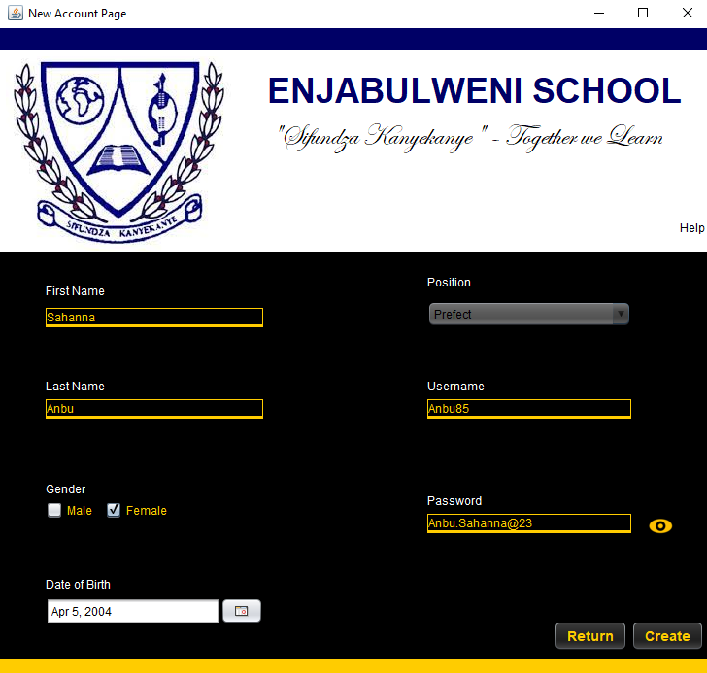

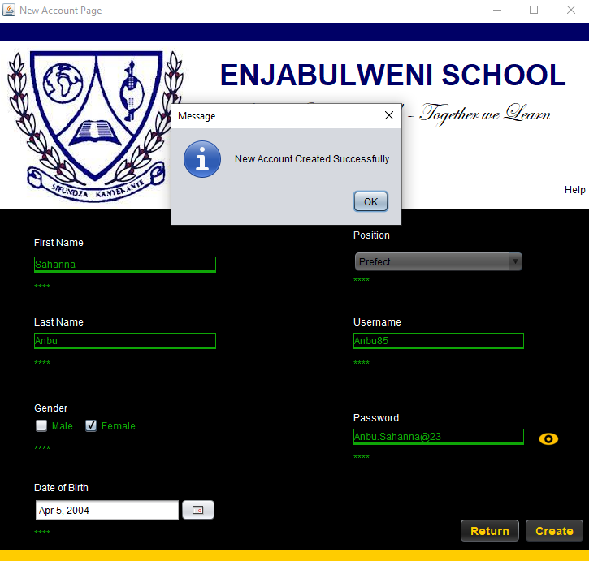

Result:

### **Extreme Data**

#### **Create New Account Page**

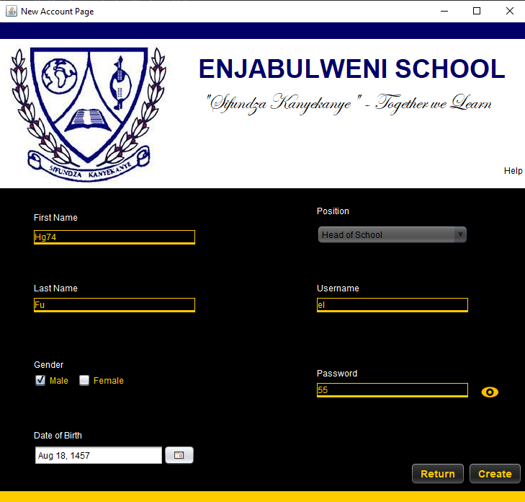  
Result:

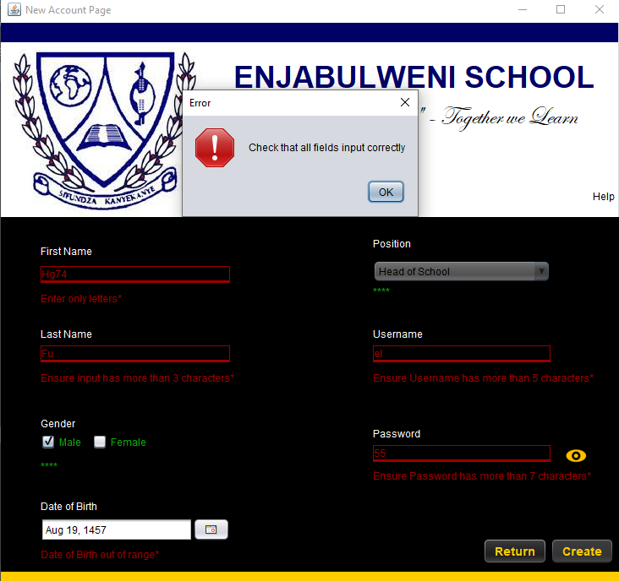

### **Abnormal Data**

#### **Create New Account Page**

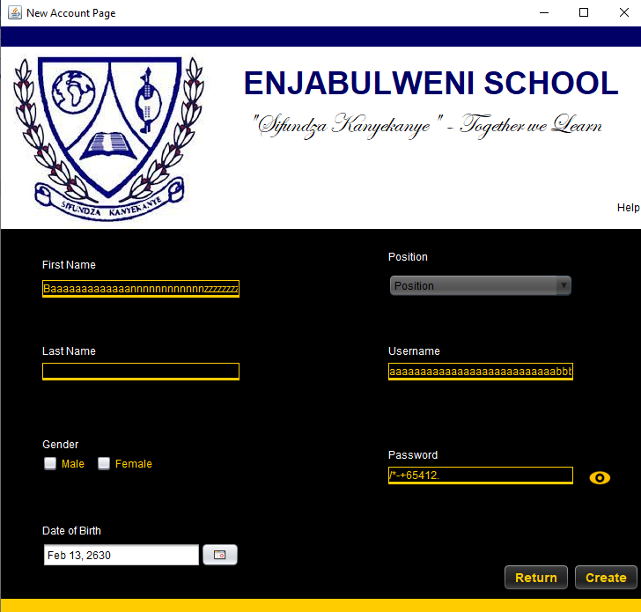  
Result:

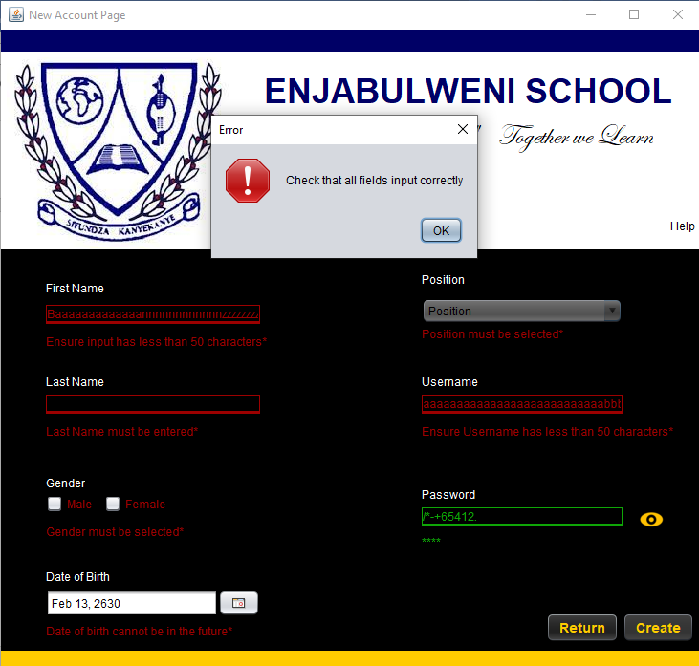

# **Evaluation of Solution**

The developed solution solves the problem that has been described in the specifications document of the project. A high-quality user experience is provided, an efficient way to store student data and data regarding their offences has also been provided and the system also serves as a useful element that the school could come to implement. The only possible improvement that could be implemented would be a safer and more secure method of allowing the user to reset their password, the addition of a ‘Confirm Password’ field in the Create New Account screen, the changing of the color of the Tables in the forms and the inclusion of a color changing password eye in the system but as a whole, the system is of a high-quality.